**US 002-TC 002_001:** **Verify Standard User Login.**

Step 2: Enter username. username- standard_user

Step 3: Enter password. Password-secret_sauce

Step 4: Click on Login button

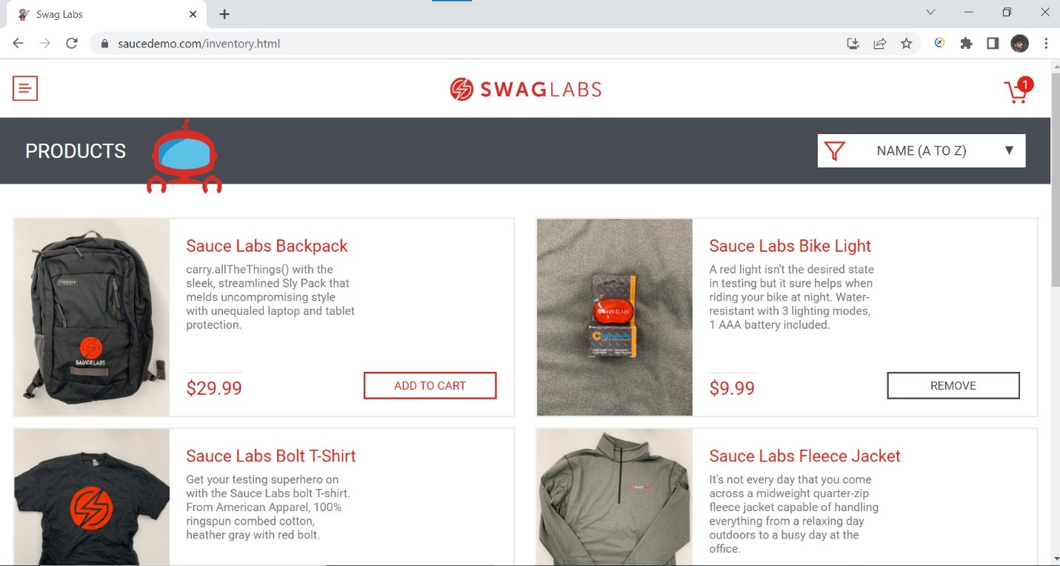

**Standard user is able to login.**

**Test case passed.**